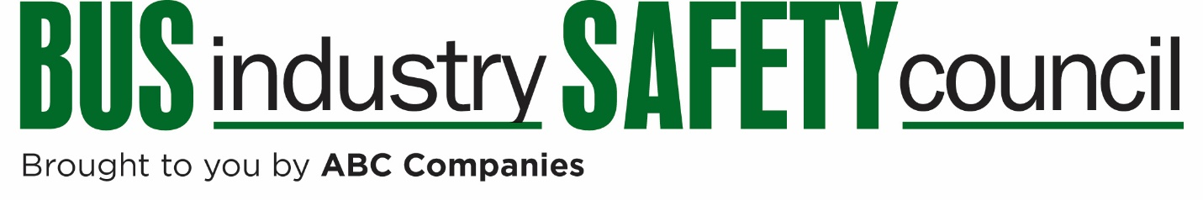
BISC Vehicle Technical Operations Committee
Meeting Agenda
November 17, 2017
10:00 AM ET
Chair  Matt Herr  Executive Coach Inc.  Lancaster, PA  Matt@executivecoach.net | Vice Chair  Jeffrey Gilchrist  Prevost  Ste. Claire, QC  jeffrey.gilchrist@volvo.com
To Access the Call:
Dial: (800) 220-9875
Passcode: 37191286
Discussion Topics
- Review of BISC West
- Vehicle-related Regulatory Update
- BISC Summer Meeting Recap
- Winter Meeting Preview: 2 ADAS seminars covering items such as TPMS, ABS, ESC, Suppression Systems.

Topics for future meetings?

